**EEOB 563 Final Project**

**Topic: Evolution of Cultivated wheat**

**Ann Murithi**

**Graduate Candidate: IGG**

**Spring 2021**

**GIT Files**

[**https://github.com/AnnM-511/Final-Project**](https://github.com/AnnM-511/Final-Project)

**Introduction**

Cultivated wheat belongs to the genus Triticum L. which includes cultivated and wild species. Triticum is made up of six species; *Tritucum monococcum* (AA genome), *Triticum urartu* (AA genome), *Triticum Turgidum* (AABB genome), *Triticum timopheevii* (AAGG genome)*, Triticum aestivum* (AABBDD genome) and *Triticum zhukovskyi* (AAAAGG genome) (Gornicki, et al., 2004). The species are further grouped into those belonging to diploid species (monococcon), tetraploid (Dicoccoidea) and Triticum (consisting of hexaploid species). The hexaploid arose under cultivation after the domestication of diploid and tetraploid species in the last 10,000 years. *T. aestuvim* arose from the hybridization between cultivated *T. turgidum* and diploid goatgrass Aegilop tauschii with DD genome, while *T. zhukovskyi* originated from hybridization of *T. monococcum* a diploid with *T.timopheevii*. The two hexaploid make up two lineages of polyploid wheat; one, Emmer lineage that consists of *T. aestivum* and *T. turgidum, while T.timopheevii* and *T. zhukovskyi* make up the Timopheevii lineage (Gornicki, et al., 2004).

*Triticum urartu* with AA genome is believed to be the male parent contributing the A genome in both lineages, while *Aegilops* is the female donor believed to have contributed the remaining two genomes of the hexaploid genomes. From the work of several Japanese wheat geneticists, *Aegilops* were divided into three major genomic groups, C, D, and S. The C-genome group included two species; the D-genome group included four species; and the S-genome group consisted of three species of the*Sitopsis*section*: Ae. longissima (including Ae.sharonensis), Ae. bicornis (and Ae. speltoides Tausch.* Within the S-genome, current taxonomy recognizes five diploid species carrying the S-genome: Ae. speltoides including ssp. ligustica (Savign.) Fiori (SS) and ssp. speltoides Boiss., Ae. bicornis (SbSb), Ae. searsii (SsSs), Ae. sharonensis (SshSsh), and Ae. longissima (SlSl) (Alevtian & Ekateriana, 2018).

The knowledge of the sources of the genomic constitution of wheat is crucial to wheat improvement. This is mostly due to the ability of wheat genome to pair either within across genome of distant relatives, creating a wide genetic pool for sources of genetic variation for agronomic important traits such as pest and disease resistant and grain quality (O'Brien & DePauw, 2004). Although many agronomically useful genes have already been transferred from *Aegilops* to common wheat varieties or breeding lines, their genetic potential in broadening genetic diversity of wheat is not fully exploited. Utilization of gene pool of *Aegilops* requires good knowledge of genetics and genomics of these species, including their genome and distribution of their genomes across the two lineages of Triticum.

Despite the wide knowledge of genome organization of the *Aegilops* debates over the origin of the B genome and therefore the cytoplasm of *T. turgidum* have spanned over decades with several hypotheses of the origin proposed. In one hypothesis, *Aegilops* is proposed as a possible donor, in which B and G genomes could have been derived from different genotypes of *Aegilops*. This is possible due to its diverse plasmon and outcrossing nature of *Aegilops.* Although the second hypothesis was contradicted by molecular and morphological data, it postulates the origin of the B genome to be in the *Sitopsis* section of *Aegilops* (Gornicki, et al., 2004). And lastly, it is also possible that the donor of B genome could be extinct or has yet to be collected. In a bid to decipher the source of the female genome, this paper extracted and utilized the chloroplast genome of 20 genotypes to construct a phylogenetic tree to show the divergence of the Emmer and Timopheevii lineage and the sources of each genome that define these species.

**METHOD**

**Material**

To replicate the work that had been done, I data of the materials used in this analysis from Genbank using the accession numbers provided in the paper.

Table 1: Description of materials making up the taxa for the phylogenetic analysis.

|  |  |  |  |  |  |
| --- | --- | --- | --- | --- | --- |
| **Organisms - Species** | **Cultivar** | **Gene Bank accession** | **Common name** | **Ploidy** | **Lineage** |
| Triticum aestivum | Chinese Spring | KJ614396.1 | Bread wheat | Hexaploid (AABBDD) | Emmer |
| Triticum aestivum | spleta | KJ614403.1 | Bread wheat | Hexaploid (AABBDD) | Emmer |
| Triticum turgidum | TA2836 | KJ614397.1 | ssp. carthlicum | Tetraploid (AABB genome) | Emmer |
| Triticum turgidum | TA2801 | KJ614399.1 | ssp. carthlicum | Tetraploid (AABB genome) | Emmer |
| Triticum turgidum | PI520121 | KJ614398.1 | ssp. durum | Tetraploid (AABB genome) | Emmer |
| Triticum turgidum | TA0073 | KJ614400.1 | ssp. dicoccoides | Tetraploid (AABB genome) | Emmer |
| Triticum turgidum | TA0060 | KJ614401.1 | ssp. dicoccoides | Tetraploid (AABB genome) | Emmer |
| Aegilops speltoides | AE918 | KJ614404.1 | ssp. ligustica | Tetraploid (AABB genome) |  |
| Aegilops speltoides | PI487232 | KJ614406.1 | ssp. ligustica | Diploid (DD genome) |  |
| Aegilops speltoides | TA1796 | KJ614405.1 | ssp. ligustica | Diploid (DD genome) |  |
| Triticum timopheevii | TA0941 | KJ614407.1 | ssp. armeniacum | Tetraploid (AAGG genome) | Timopheevii |
| Triticum timopheevii | TA944 | KJ614409.1 | ssp. armeniacum | Tetraploid (AAGG genome) | Timopheevii |
| Triticum timopheevii | TA1485 | KJ614408.1 | ssp. armeniacum | Tetraploid (AAGG genome) | Timopheevii |
| Aegilops bicornis | Clae57 | KJ614418.1 | Goat grass | Diplod (SbSb Genome) |  |
| Aegilops searsii | TA1926 | KJ614413.1 | Goat grass | Diplod (SsSs Genome) |  |
| Aegilops searsii | TA1837 | KJ614414.1 | Goat grass | Diplod (SsSs Genome) |  |
| Aegilops searsii | TA1841 | KJ614415.1 | Goat grass | Diplod (SsSs Genome) |  |
| Aegilops sharonensis | TA1995 | KJ614419.1 | Goat grass | Diplod (SshSsh genome) |  |
| Aegilops sharonensis | TA1996 | KJ614417.1 | Goat grass | Diplod (SshSsh genome) |  |
| Aegilops longissima | TA1924 | KJ614416.1 | Goat grass | Diplod (SlSl genome) |  |
| Aegilops kotschyi | TA1980 | KJ614420.1 | Goat grass |  |  |
| Triticum urartu | PI428335 | KJ614411.1 |  | Diploid (AA genome) |  |
| Aegilops tauschii | AL8/78 | KJ614412.1 | Goat grass | Diplod (DD genome) |  |
| Hordeum vulgare | Morex | EF115541.1 | Barley |  |  |
| Triticum Zhukovskyi** |  |  |  | Hexaploid (AAAAGG) | Timopheevii |

**2. Sequence alignment and phylogeny analysis**

Nucleotide sequence of whole chloroplast genome were extracted from Genbank in FASTA format to note pad. Hordeum *vulgare* (barley) was added to the extraction and to be set as an outgroup. Barley belong to the *triticae* tribe composed of 300 species, which includes wheat and all its relatives. The sequences were aligned using MAFFT program installed in HPC class. The Phylogenetic analysis was performed using Phylip. Neighbor joining was done based on Jukes-Cantor distance substitution. Bootstrap values were calculated using default setting, at 100 replicates. A majority rule maximum likelihood tree in RAxML using GTR-G model was also generated. To test other programs available for phylogenetic analysis and compare the results with programs used in class, I used MEGA X to generate phylogenetic trees using the same data.

**Results and Discussion**

The chloroplast genome used in this case is composed of 131 genes with an average sequence size of 135781 – 136000 bp across all the species used. The topology of the neighbor – joining and ML in this analysis were the same. From the analysis I developed MP, NJ, and ML trees.

**Figure 1:** MP phylogenetic tree of Triticum species and Agielops based on their chloroplast genome. Analaysis done using MEGA X.

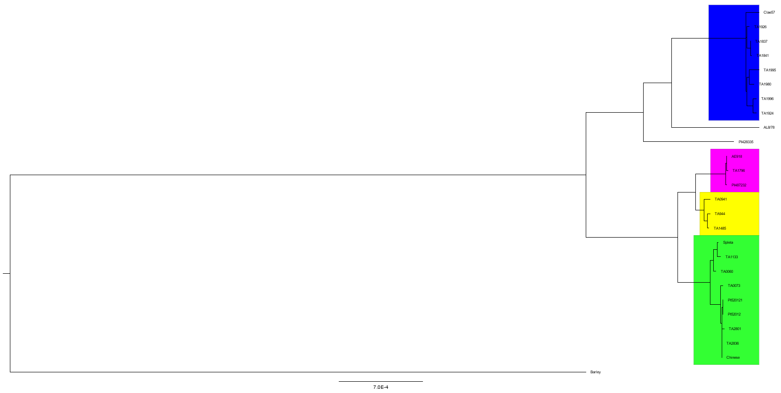

**Figure 2:** Neighbor joining (NJ) phylogenetic tree of Triticum species and Agielops based on their chloroplast genome. Barley was used as an outgroup. Colouring in the clades reprsents grouping of taxa on the tree

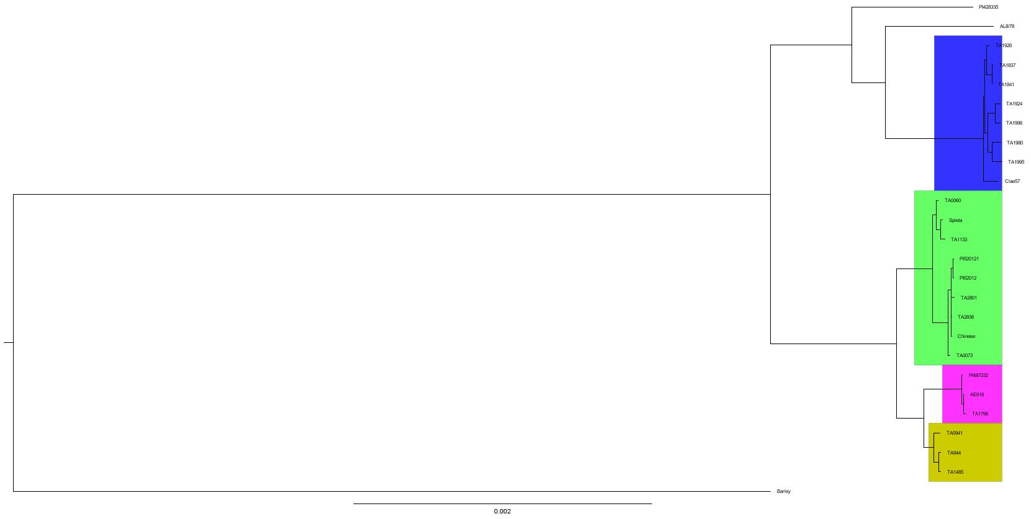

**Figure 3:** Maximum likelihood phylogenetic tree based of relationship between Triticum and Aegilops based on their chloroplast genome. The tree was built using RaxML-NG. Barley was used as an outgroup. Colors on clades represents grouping of taxa on the tree

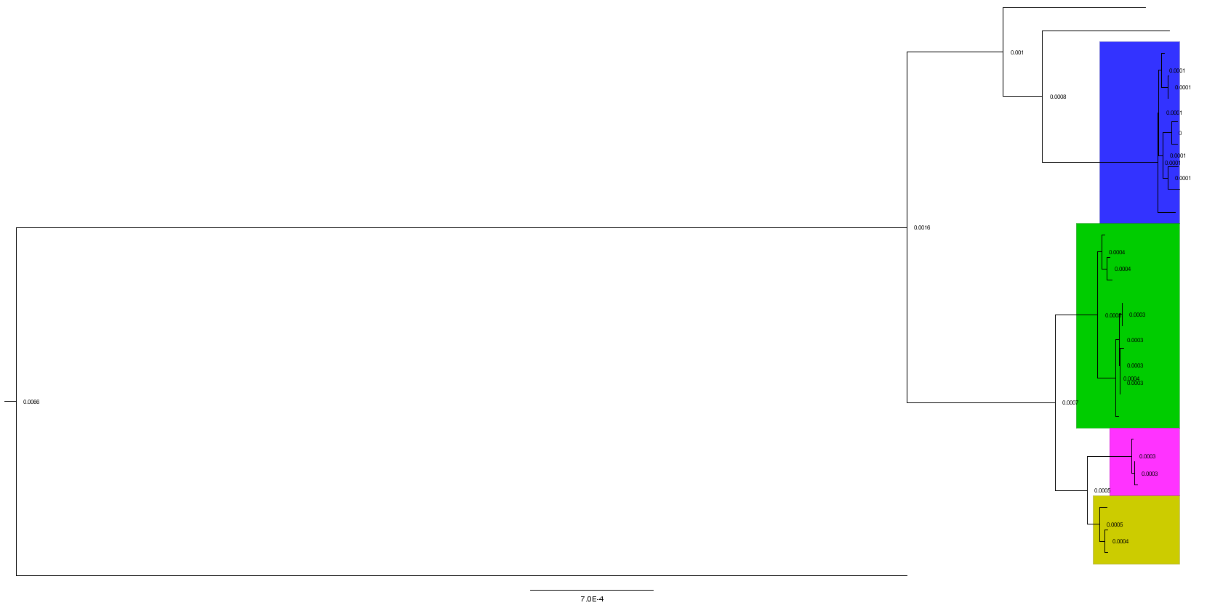

**Figure 4:** Maximum likelihood phylogenetic tree based of relationship between Triticum and Aegilops, based on their chloroplast genome. The tree was built using RaxML-NG with 1000 bootstraps. Barley was used as an outgroup. Colors on clades represents grouping of taxa on the tree

**Figure 5:** ML phylogenetic tree of Triticum species and Agielops based on their chloroplast genome. Analysis done using MEGA X.

The topology of the NJ tree ML and ML-bootstrap tree was all the same (Figure 2-4). Indicating a strong signal of relatedness among the individuals in the taxa. Consecutively, MP tree (Figure 1) was slightly different, although it groups the taxa into their respective ploidy state, it does not say much about the phylogenetic relationship among the taxa of different ploidy level.

The phylogenetic tree construction here show grouping of two main clades. The two clades have been formed on the bases of their ploidy level; the diploid form the top clade (blue) while the polyploid cluster in the bottom clade. Interestingly, the A. *speltoides*, all diploids, form a small clade within the polyploid clade, shown in purple. The clade forming the polyploid is further grouped into Emmer and Timopheevii lineages, both in green and yellow respectively. The Emmer clade further divides into two clades of two *aestivum,* theSpleta and Chinese Spring cultivars. Spleta cultivar groupes with spp. dicocoides a subspecies of T.*turgidum*. This could suggest the origin of the two thirds of Spleta genome, while that of Chinese Spring can be explained by either the durum or carthlicum subspecies of T.*turgidum*. The Timopheevii on the other hand shares a close ancestor with A*. speltoides*. Considering this relationship, the A. *spletoids* is the only conclusion as to the source of the G genome of the Timopheevii lineage. Cytoplasm analysis also were also consistent with these results, confirming the source of the female (cytoplasm) to be the A. *spletoids* (Gornicki, et al., 2004)*.*

Two other diploid T. *urartu* and A.*tauschii* group individually and separate from the rest of the main clades. Since they are both diploid, they branch on the diploid clade. T. *urartu* looks to have diverged earlier than all the diploid in the Aegilops genus, suggesting that they diverged from T. *urartu*. Since T. urartu and A.tauschii are the male donors of the polyploid species, all species in this in this clade form the paternal clade, thus confirming the A.*speltoides* to be the maternal donors.

Notably, sequence divergence within each cluster was low and could explain why tree generated from MEGA 5 software were not able to show the distinct differences in each cluster (Figure). All the diploids and polyploids formed two separate main clades. Interestingly, in this tree, the two clades seem to come from a divergence in T.*urartu* and T.*tauschii* is grouped with all the diploids. This also indicates that the T. *urartu* diverged before the maternal donors of the polyploid species.

The mystery surrounding the source of the B genome is however not solved. Two hypotheses still stand, in which a distant relative of A. *Speltoides* could be the source and is now extinct or that the polydization of Emmer lineage happened earlier than that of Timopheevii. The knowledge of the B genome would play a crucial role in wheat breeding.

# **References**

Alevtian, R., & Ekateriana, B. D. (2018). Evolution of the S-Genomes in Triticum-Aegilops Alliance: Evidences From Chromosome Analysis. *Frontiers in Plant science, 9*, 1756. doi:10.3389/fpls.2018.01756

Gornicki, P., Zhu, H., Wang, J., Challa, G. S., Zhang, Z., Gill, B. S., & Li, W. (2004). The chloroplast view of the evolution of polyploid wheat. *New Phytologist, 204*(3), 704-714.

O'Brien, L., & DePauw, R. (2004). Wheat breeding. In C. Wrigley, *Encyclopedia of Grain science* (pp. 330-336). Elsevier.